Lab 5 Report

1. Objectives
Learn Docker basics: images, containers, ports, volumes, and multi-container setup through official Docker tutorials.

2. Environment Setup
Verified Docker and Docker Compose installation on macOS.
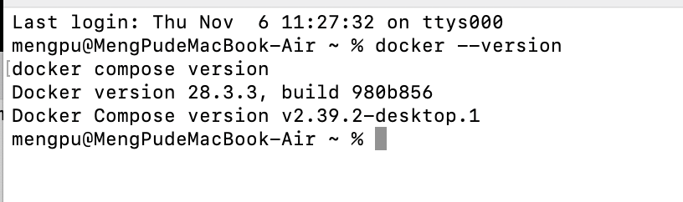
Screenshot : Docker and Docker Compose version output confirming successful installation.

3. Experiments and Screenshots

Step 1: What is a Container
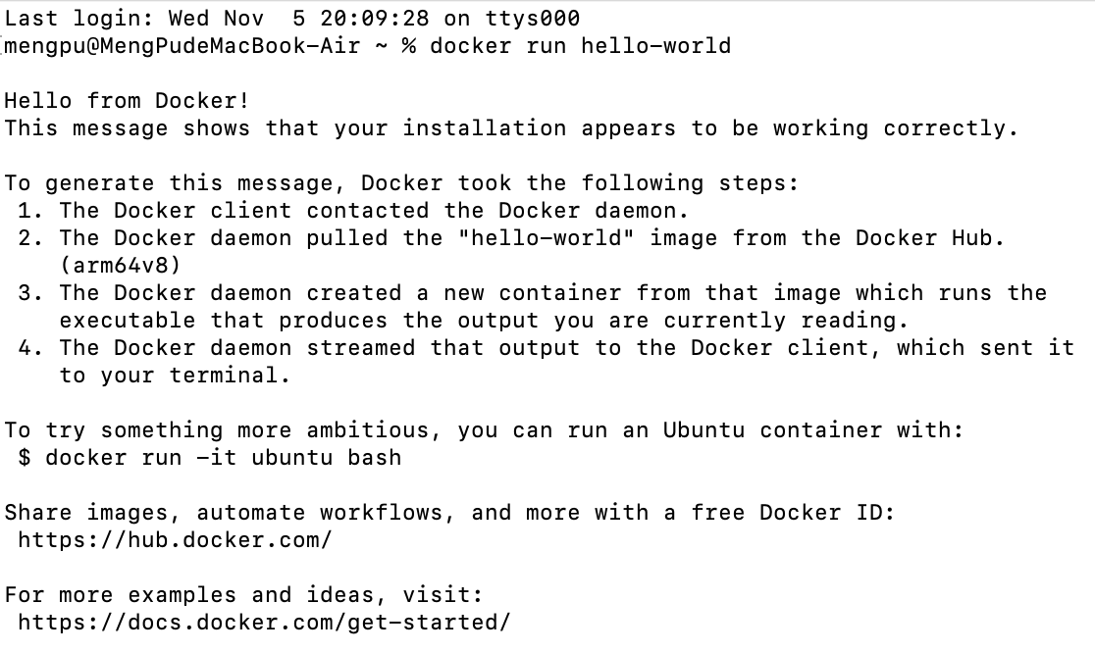
Screenshot : Output of 'docker run hello-world', confirming that Docker client and daemon are communicating correctly.

Step 2: What is an Image
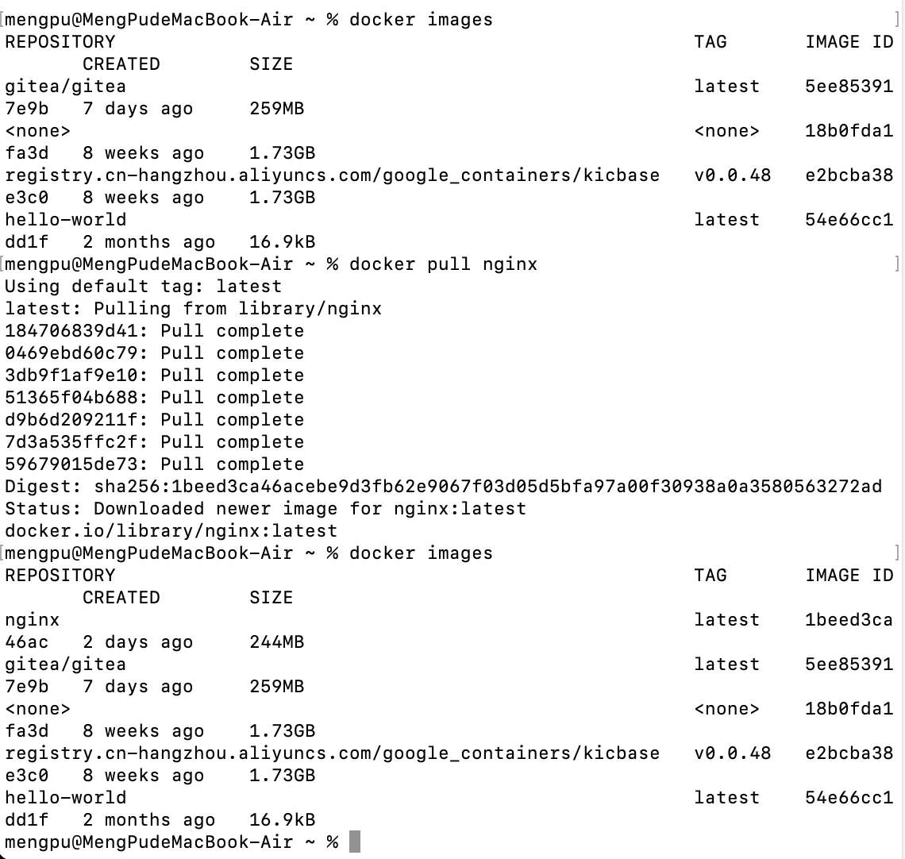
Screenshot : Nginx image successfully pulled and listed using 'docker images'. Docker images serve as templates for containers.

Step 3: What is Docker Compose
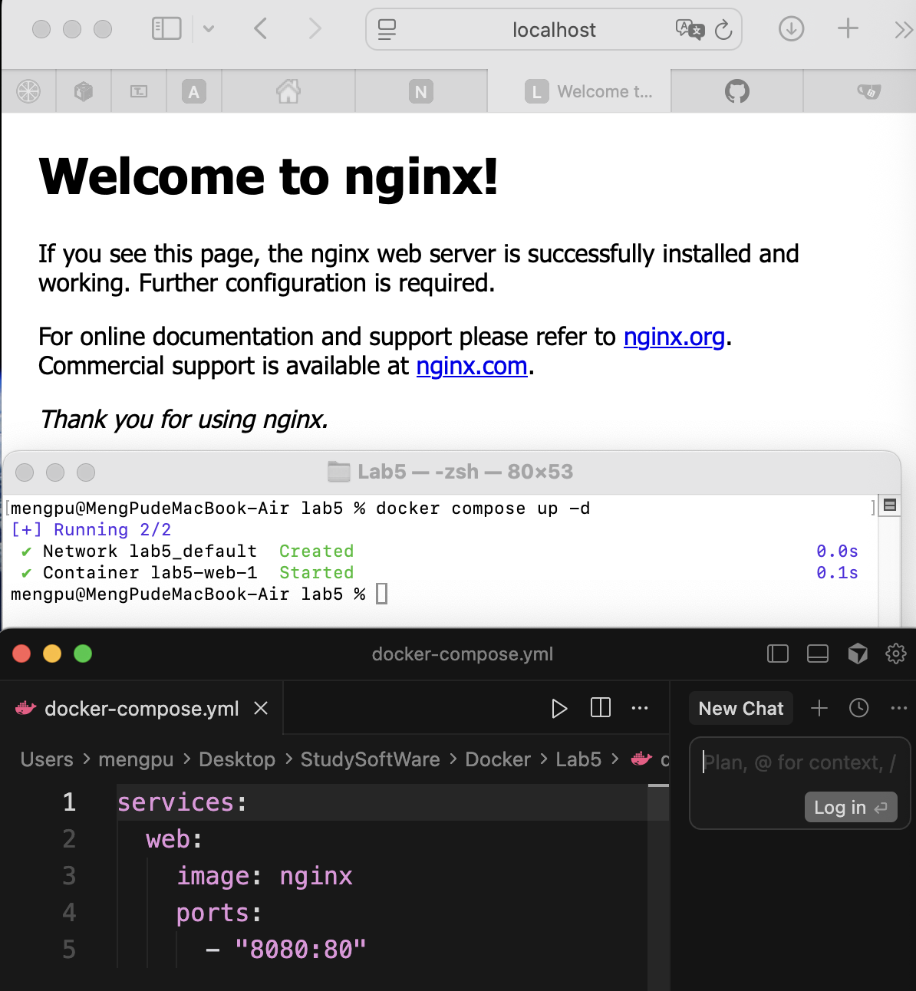
Screenshot : Nginx web server successfully deployed using docker-compose.yml and accessible via localhost:8080.

Step 4: Publishing Ports
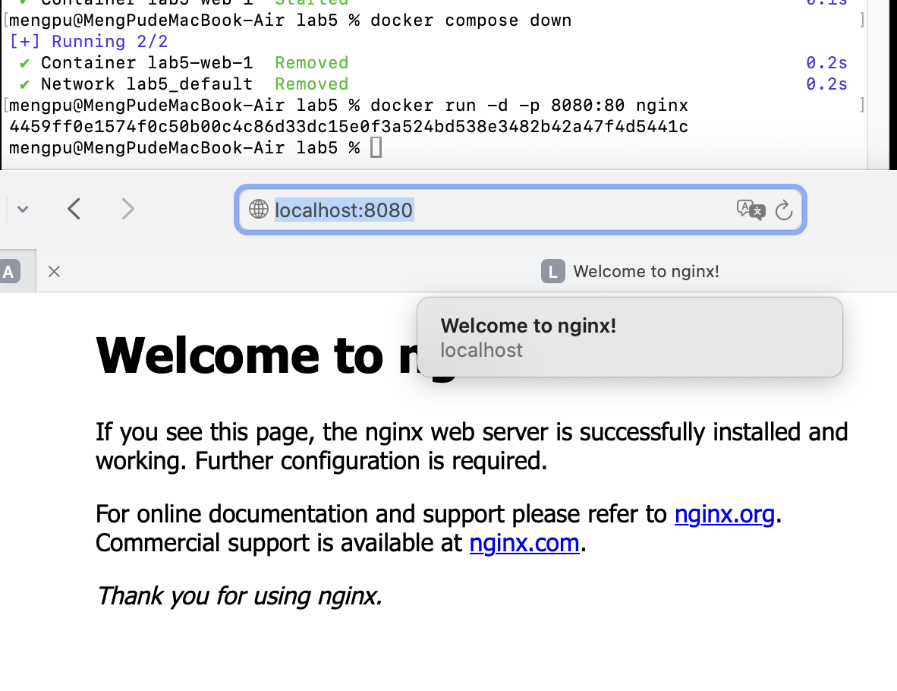
Screenshot : Demonstrates port mapping (8080:80) where the Nginx welcome page is accessed through the host browser.

Step 5: Overriding Container Defaults
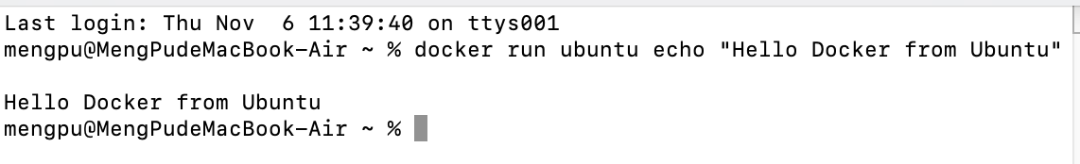
Screenshot : Shows overriding the default CMD using 'docker run ubuntu echo “Hello Docker from Ubuntu”'.

Step 6: Persisting Container Data
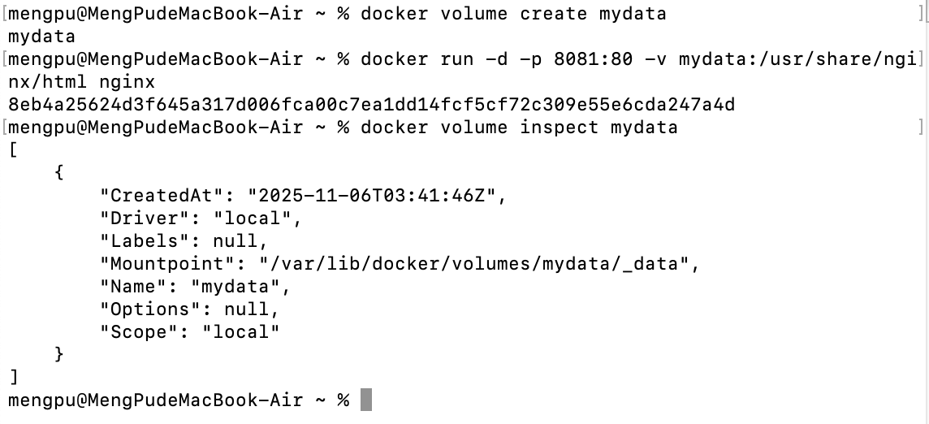
Screenshot : Created and inspected Docker volume 'mydata' for persistent storage across container restarts.

Step 7: Sharing Local Files
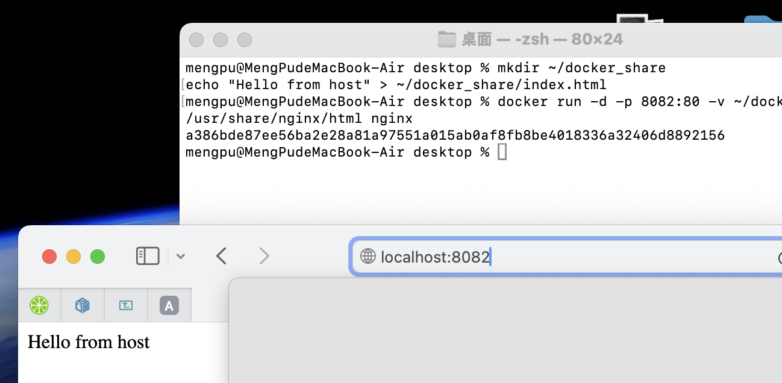
Screenshot : Local directory mounted into container using -v flag, enabling file sharing between host and container.

Step 8: Multi-Container Applications
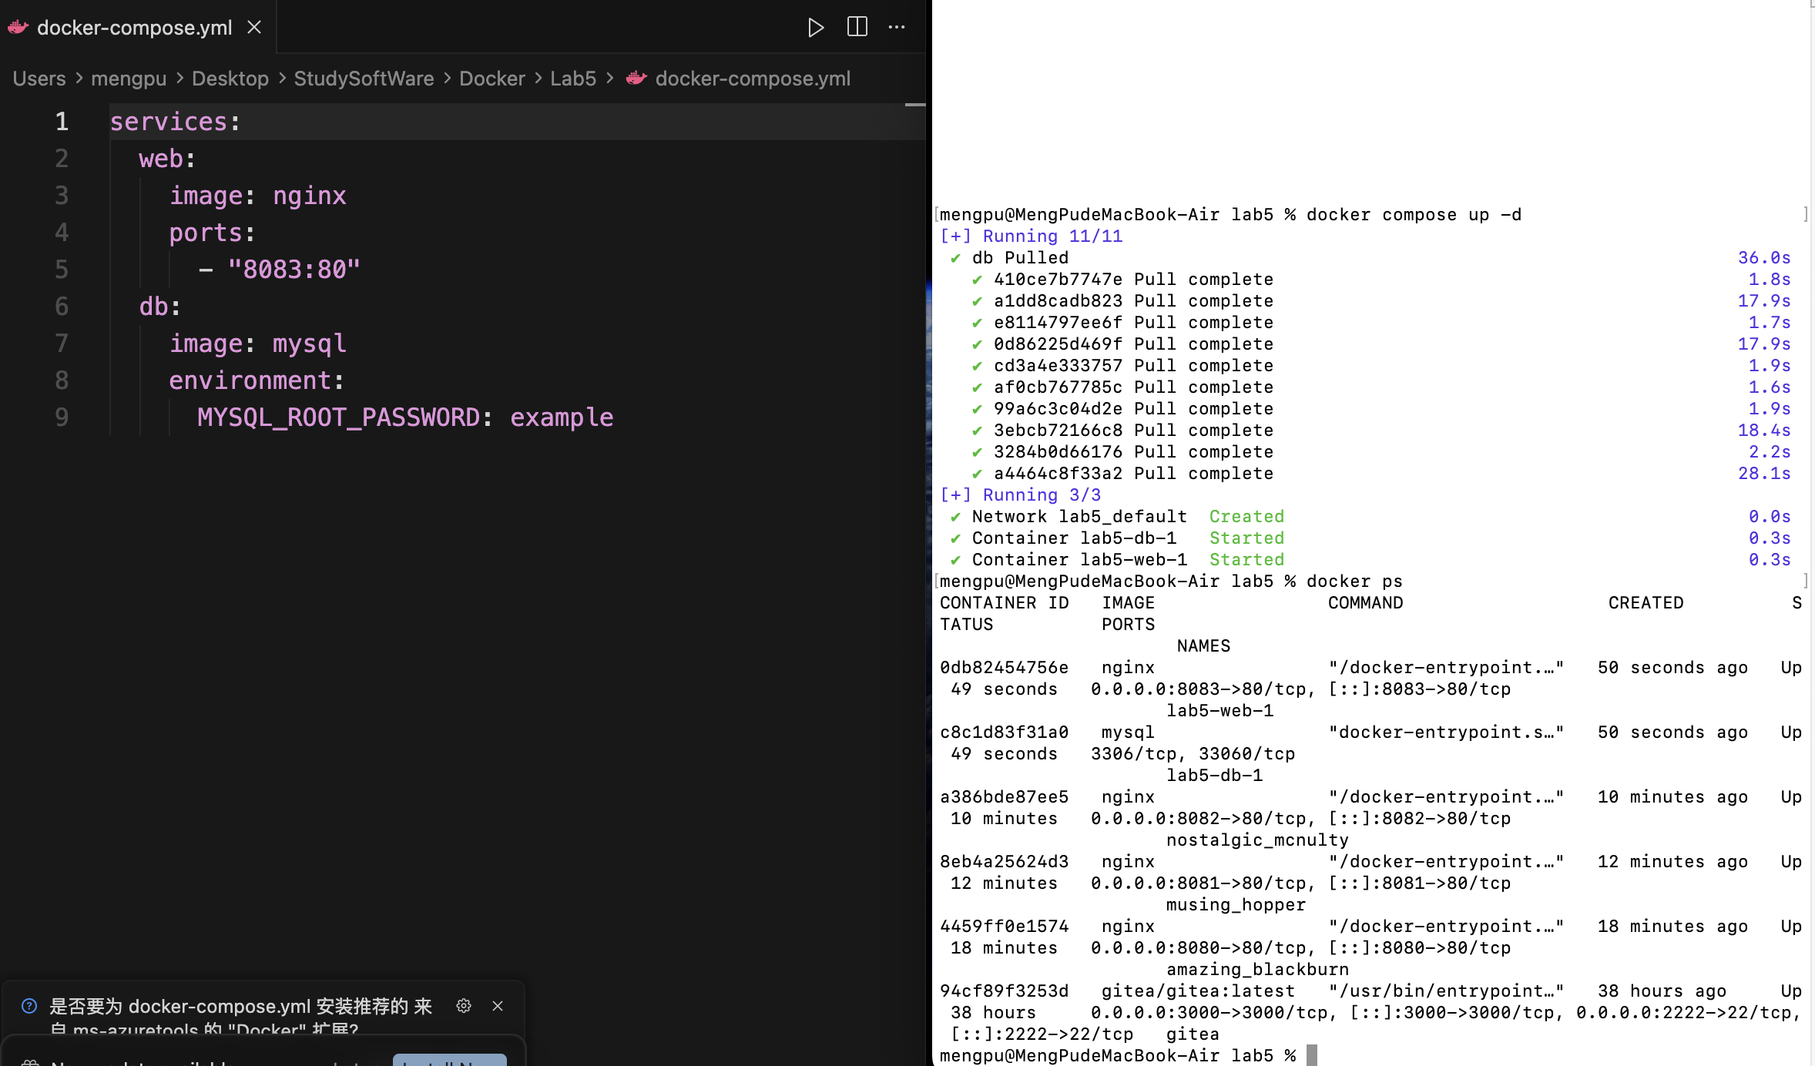
Screenshot : Multi-container setup with Nginx and MySQL running simultaneously, managed via Docker Compose.

4. Reflection
Through this lab, the understanding of Docker concepts has been significantly deepened. Containers provide isolation, consistency, and portability across different environments, making application deployment faster and more reliable compared to traditional virtual machines. By exploring Docker images, I learned how applications and their dependencies are encapsulated into lightweight, reusable templates that can be easily shared and versioned.
The experiments with Docker Compose demonstrated how multi-container orchestration simplifies the management of complex applications, allowing multiple services such as web servers and databases to be deployed and networked automatically. Furthermore, configuring port mapping and shared volumes emphasized the importance of persistent data storage and flexible communication between the host and containerized services.
Overriding container defaults and sharing local files provided valuable insight into customizing container behavior and integrating development workflows efficiently.
Overall, this lab enhanced not only my technical understanding of containerization but also my practical ability to design, deploy, and manage Docker-based environments that mirror real-world cloud and DevOps scenarios.

